Lexical analyzer

Lexical analyzer is a first phase of the compiler.

Modus operandi:
token
character stream
Source program
Lexical analyzer
parser

Get next token

Symbol table

Lexical analyzer scans an input and produces stream of tokens. Basically each word of the source program is a token.
Each token is passed to parser that checks it and asks for a next token.

If it is a new token in several cases this token is added to the symbol table.

Lexical structure of tokens is specified using regular expressions (well defined formal language specification).

Lexical analyzer has 2 purposes:
- scans the input
- analyzes it’s lexical correctness

Lexical analyzer also keeps track of the source-coordinates of each token:
  - in which file it appears,
  - token’s position – line and column number.
This is useful for debugging purposes.

Another task of the lexical analyzer is to get rid of white spaces, comments and another unimportant details.
Example of tokens

token name | token value - lexeme
ID | last my x sum
NUM | 567 67.89 82.001 4.5e-10
IF | if
COMMA | ,
NOTEQ | !=

Example of non-tokens:

type | example
comment | //this is one line comment  /* this is multi-line comment*/
white spaces | \t \n \b
preprocessor directive | #include <iostream.h>

Token is a logical unit defined by programmer.

Example

Given C code:
void match(char *mystring) /* checking is string is HELLO*/
{
if(!strncmp(mystring, ”HELLO”))
return 0;
}

Lexical analyzer will return following tokens:

VOID ID(match) LPAREN CHAR STAR ID(mystring) RPAREN LBRACE IF LPAREN BANG ID(strncmp) LPAREN ID(mystring) COMMA STRING(HELLO) RPAREN RPAREN RETURN NUM(0) SEMI RBRACE EOF

Basic tokens are numbers, keywords, types, operators and identifiers.

“Value” of token is called a lexeme.

Example
token lexeme
INT 35 1223

ID X1 SUM
REAL 25.5

Actually lexeme holds original name or value of the token.

Tokens can have attributes.

For example, if we have a token called NUMBER it can have an attribute that tells if this number is integer or real.

Symbol table

Symbol table is used throughout the compiling process to build up information about identifiers used in source program.

Usually it holds:
- variable name (or lexeme),
- its type
- additional attributes - is it a function, a class or a variable, what line it was written in, from which line it was called.

Basic symbol table data structure:
- linked list
- array
- dictionary tree.

Basic linked list symbol table example:

struct st_entry
{
char *lexeme;
int type; //or can be char * type;
char *attributes;
struct st_entry *next;
}

Lexical analyzer only adds new lexemes to the symbol table. First it checks if lexeme is already in the table:
if it is – does nothing
if not - adds it to the appropriate symbol table cell.

Basic symbol table operations

- insert(w,t) – returns index of new entry for token t and it’s lexeme w
- lookup(w) – returns entry for the lexeme w or 0 if not found
where w is token’s lexeme and t is a table name (pointer to the symbol table)

lokup() and insert() depend from data structures you’ve chosen to use. Usually it is done through hashing mechanism.

Use of symbol table

Symbol table is used mainly in front end of the compiler.

In scanner’s phase new lexemes are added to it. Later in parser phase additional attributes can be entered. In semantic analysis phase types of the identifiers can be checked. In intermediate code generation phase exact place of the lexeme is important and functional attributes of the lexeme are used.

Lexical analyzer or scanner uses regular expressions and finite automata to recognize appropriate tokens.

Some basic definitions

Language is a set of words or strings.

String is a finite sequence of letters over finite alphabet.

Alphabet is a finite set of letters. Alphabet sign is Σ. In programming languages such an alphabet is ASCII character set, but it could be UNICODE set or subset of ASCII (only English alphabet and separators).

Empty string is a string with 0 letters in it. Its sign - ε.

Regular expressions

Regular expression definitions

Basic regular expressions:

a | An ordinary character stands for itself is a regular expression.
ε | Is a regular expression. Defines an empty word.
∅ | Is a regular expression. Defines an empty language or an empty regular expression.

Some operations over basic regular expressions:

M|N  M+N | Alternation. M or N is a regular expression. Also can be written as M+N.
M.N | Concatenation. M followed by N is a regular expression. Also can be written as MN.
M* | Repetition. Zero or more times of M is a regular expression.
M+ | Repetition. One or more times of M is a regular expression.
M? | Repetition. Zero or one occurrence of M is a regular expression.

More abbreviations:

[a-zA-Z] | Character set alternation (single character) from the set is a regular expression.
. | Any (single) character but a new-line is a regular expression.
“s” | Quotation, stands for string s itself literally.

Examples

Regular expression for all words of length 2 over English alphabet:
r = [a-zA-Z] [a-zA-Z]

Regular expression for all possible words over digits alphabet:
r=([0-9] )*

Regular expression for all words that starts from aB end ends with BC:
r = aB [a-zA-Z]* BC

Regular expression for real numbers:
r = [0-9]+”.” [0-9]* | [0-9]*”.” [0-9]+
or
r=[0-9]+”.” [0-9]* + [0-9]*”.” [0-9]+ (usage of + instead of |)

To avoid using to many parentheses, we assume that the operations have the following priority hierarchy:

operator | priority
* | - highest (do it first)
°
+ | - lowest (do it last)

Regular expression operators

|
means "or"
*
means zero or more instances of
+
means one or more instances of
?
means zero or one instance of
()
priority or grouping

More examples over Σ={a,b}:

ε, a, a+b, b*, (a+b)b, ab*, a*+b*

For each regular expression r what is a language it describes - L(r)?

Translation technique

- Once all tokens are defined (using regular expressions) automaton can be build for each regular expression.
- Unite all the automata together.
- Translate this automaton into transition table.
- Find the longest matching token accordingly to this table.

regular expression→NFA→DFA→transition table→lexical analyzer

Finite Automaton
Definition for students who did not study automata course.

Finite Automaton
is a directed graph.
Nodes in this graph represent finite set of states, one of which is a start state, several states can be final state.
Edges are transitions that tell for each state and for each symbol of alphabet which state to go to next.
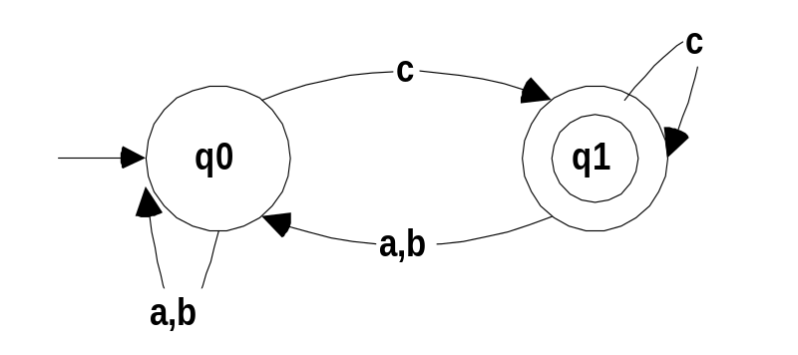
L= { w | w over {a,b,c}*
the last letter of w is c}

Graphical representation
qi
- Each state is represented by a circle.

- The transition function (called delta - δ), is represented by directed and labeled edges between states. Each edge is a directed edge with letters of alphabet written on it.

- Final states are represented by a double circle.
q0

- The start state has an incoming arrow.
q0

Modus operandi of automaton

- Reading of the string starts at start state.

- Each step only one letter of the string is read.

- After reading a letter of the string “ transitional decision” should be done:
  - which state to go to.
This decision is done accordingly to the edges of the automaton.

- Every string that ends in final state is accepted by the automaton and belongs to the automatons language.

- If automaton gets “stuck” (no transition for a given input symbol – no edge with an appropriate input symbol) then this word is illegal.

Example
Automaton A:

Which state is a final state?

Which state is a start state?

Where automaton goes from state q1 on input a? on input c?

What happens if input ends with a? with b? with c?

Let’s see if A accepts w=cabc.

We start in the start state q0. First symbol of input is c.
q0→^{c→}q1→^{a→}q0→^{b→}q0→^{c→}q1
q1 is an accepting (final) state that means w belongs to L(A).

Let’s see if A accepts w=acbb.

We start in the start state q0. First symbol of input is a.
q0→^{a→}q0→^{c→}q1→^{b→}q0→^{b→}q0
q0 is a regular not accepting state that means w does not belong to L(A).

Given several strings: abc, acacb, a, ε, cccaac.

Are those strings belong to L(A)?

DFA vs. NFA

 | DFA | NFA
name | Deterministic finite automata | Non-deterministic finite automata
transitions | 1. no ε transitions  2. for each input character exist only one transition | 1. ε transitions are allowed  2. for each input character several transitions are allowed
word paths | Single path | Multiple paths

Example L = { w | w over {0,1}* and w starts and ends with 0 and after each 1 should be 0 }
NFA:
1
eX
0
q1
0
q2
q0

DFA:
0,1
1
0
0
0
1
1
q1
q0
q2
q3

Translation of regular expression into automaton

Regular expression a translated into following automaton:
a
i
start
f

Regular expression M|N translated into following automaton:

M+N
i
start
f

Regular expression M.N translated into following automaton:

N
i
start
f
k
M

Regular expression M* translated into following automaton:
M

f
ε
ε
start
i

Regular expression M⁺ translated into following automaton:
M
M
start
f
i

Union of all automata is done in easy way.

Add new start symbol q0 and connect it to the starting states of all regular expression automata with ε-transitions.
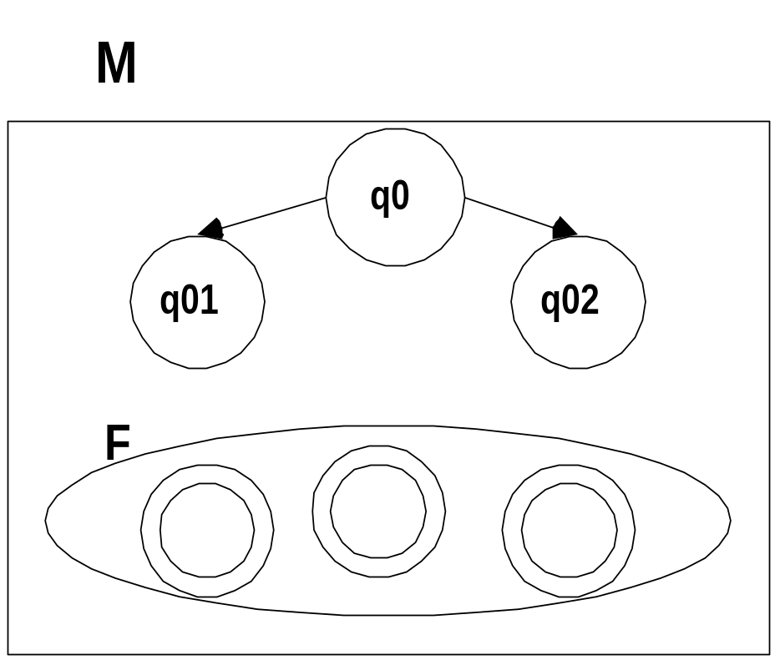
ε
ε

regular expression→NFA→DFA→transition table→lexical analyzer

Basic definitions

closure(q) – is a set of all states that can be reached from q with ε-transitions only.
1
eX
e,0X
q1
0
q2
q0

closure(q0)={q0,q1,q2}
closure(q1)={q1,q2}

move(T,a) – is a set of all states that can be reached on input a from some state T of NFA.
q0
q1
q0
0

0,1

0
0

move(q0,0)={q0,q1} move(q1,1)=״ move({q0,q1},1)={q1}

Simulating an NFA on input string

Input: NFA N string x
Output: “yes” if N accepts x, “no” otherwise

Algorithm
state = closure(q0);
a = nextchar;
while a!= end_of_word
{ state = closure(move(state,a));
a = nextchar;}
if (state∩F (final state set) = = ״)
then return “no”
else return “yes”

Example
1
1
0
eX
eX
0
1
2
3

Does w=110 belong to automaton language?

state input ns=move(state,input) closure(ns)
closure(0)=0 1 1 1
1 1 2 2,0
2,0 0 ∅U3=3 3,0
3,0 end_of_the_word
0 is final state.

Result: w=110 belongs to the automaton language

Does w=10 belong to automaton language?

state input ns=move(state,input) closure(ns)
closure(0)=0 1 1 1
1 0 not defined=∅
End of the word is not reached.
Result: w=10 does not belong to the automaton language.

Does w=1 belong to automaton language?

state input ns=move(state,input) closure(ns)
closure(0)=0 1 1 1
1 end_of_the_word
1 a regular state.
Result: w=1 does not belong to the automaton language.
Convert an NFA to an equivalent DFA

States in converted DFA will be set of states from NFA. DFA simulates “in parallel” all possible moves of NFA on given input.

Algorithm for converting NFA into DFA
1. DFAstates = {closure(q0)}; and it is unmarked
2. while there is an unmarked state T in DFAstates
{
mark T;
for each input symbol a
{
U = closure(move(T,a));
if U is not in DFAstates
then add U to DFAstates as unmarked state
transition[T][a] = U;
}
}
3. States with final state in it are also final states in resulting DFA.
4. Start state is {closure(q0)}

Array transition holds transition functions δ of resulting DFA.
regular expression→NFA→DFA→transition table→lexical analyzer

Dry run of the algorithm
1
eX
0
q1
0
q2
q0

A:

DFAstates={closure(q0)}={{q0,q1}}

Unmarked state {q0,q1}:
Mark {q0,q1}
For 0 U=closure(move({q0,q1},0))=closure({q2})={q2};
Add {q2} to DFAstates: DFAstates={ {q0,q1}’,{q2}}
transition[{q0,q1}][0]={q2}
For 1 U=closure(move({q0,q1},1))=closure({q1})={q1};
Add {q1} to DFAstates: DFAstates={ {q0,q1}’,{q2},{q1}}
transition[{q0,q1}][1]= ״

Next unmarked state {q1}:
Mark {q1}
For 0 U=closure(move({q1},0))=closure({q2})={q2};
{q2}is in DFAstates no addition
transition[{q1}][0]={q2}
For 1 U=closure(move({q1},1))=closure(״)= ״;
Add ״ to DFAstates: DFAstates={ {q0,q1}’,{q2},{q1}’, ״ }
transition[{q1}][1]= ״

Next unmarked state {q2}:
Mark {q2}
For 0 U=closure(move({q2},0))=closure({q2})={q2};
{q2}is in DFAstates no addition:
DFAstates={ {q0,q1}’,{q2}’,{q1}’, ״ }
transition[{q2}][0]={q2}
For 1 U=closure(move({q2},1))=closure({q1})= {q1};
{q1}is in DFAstates no addition
transition[{q2}][1]= {q1}

Next unmarked state ״ :
Mark ״
For 0 U=closure(move(״,0))=closure(״)= ״;
״ is in DFAstates no addition
transition[״][0]= ״
For 1 U=closure(move(״,1))=closure(״)= ״;
״ is in DFAstates no addition
transition[״][1]= ״

Resulting transition table:
state | 0 | 1
{q0,q1} | {q2} | ״
{q1} | {q2} | ״
{q2} | {q2} | {q1}
״ | ״ | ״

Resulting DFA automaton is:
0,1

״
1
q1
1
q0,q1

0
0
1

q2

0

Transition table

Transition table is a matrix or a two dimensional array.

Transition table rows are states of the DFA automata and its columns are letters of the alphabet (in our case ASCII code).

int transition[States][256]=
{ /* ... 0,1,...a,b,...*/
/*state 0*/ {0,0,0,..,0,0,...0,0,0...},
/*state 1*/ {0,0,0,..,3,5,...0,0,0...},
…
}
where transition[3]['a']= 5 means that from state 3 we move to state 5 when 'a' is an input letter.

transition[state][char] has exactly one place to go to.
Why? We use a DFA automaton to build it.
Example of building a transitional table for a following language:
L - language of arithmetical expressions over Σ={0,1,2,3,4,5,6,7,8,9,.,+,-,*,/,=,(,)}.

First let’s recognize our tokens
integer number: 0+[1-9][0-9]*
real number: 0.[0-9]⁺+[1-9][0-9]* .[0-9]⁺
plus: +
minus: -
multiplication: *
division: /
equality: =
left parthesis: (
right parathesis: )

Now let’s build an automaton for L.

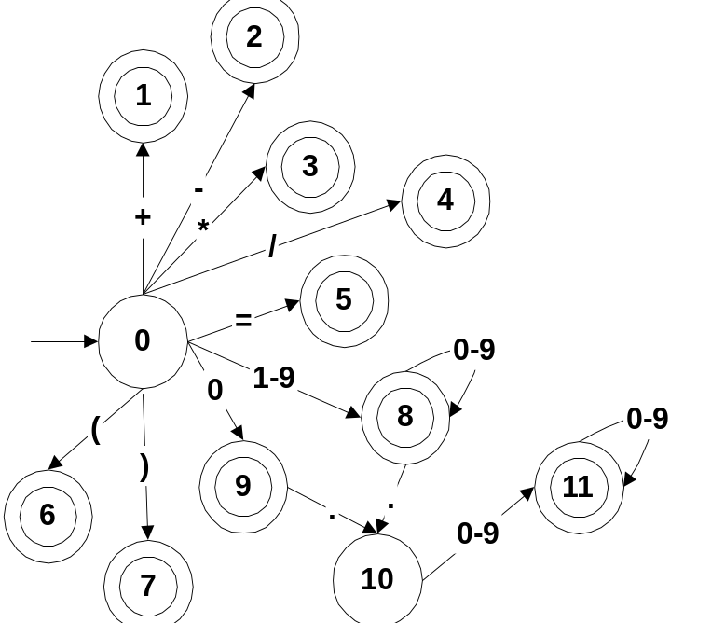

Resulting automaton has 12 states. Alphabet Σ has 18 letters. Resulting transition table size is 12X18.

transition[12][18]=

state | + | - | * | / | = | ( | ) | . | 0 | 1 | 2 | 3 | 4 | 5 | 6 | 7 | 8 | 9
0 | 1 | 2 | 3 | 4 | 5 | 6 | 7 |  | 9 | 8 | 8 | 8 | 8 | 8 | 8 | 8 | 8 | 8
1  ..  7 |  |  |  |  | n | o |  | m | o | v | e
8 |  |  |  |  |  |  |  | 10 | 8 | 8 | 8 | 8 | 8 | 8 | 8 | 8 | 8 | 8
9 |  |  |  |  |  |  |  | 10
10 |  |  |  |  |  |  |  |  | 11 | 11 | 11 | 11 | 11 | 11 | 11 | 11 | 11 | 11
11 |  |  |  |  |  |  |  |  | 11 | 11 | 11 | 11 | 11 | 11 | 11 | 11 | 11 | 11

All empty cells are lexical errors for the current state.

Usually negative values are putted in lexical error cells.
We will put –1.

Sometimes error recovery routines can be proposed. Error recovery routine can fix a given source program by adding, deleting or updating symbols.

In this case number of specific error recovery routine is putted into the table.

For example:
transition[k][j]=e2 or err5.
regular expression→NFA→DFA→transition table→lexical analyzer
Token recognition policy

1. If in some point two tokens can be recognized the longest one should be return.

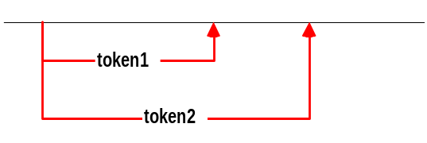
2. If lexeme matches two tokens then the first one in order of the rules will be returned. Example: while can match reserved word token and can match identifier token.

Lexical analyzer looks several chars forward before it matches next token.

For example if lexical analyzer scans 3<>5:
3 < > 5

it can recognize several tokens:
< or
<= or
<>

That is why even when DFA is in accepting state (for “< “) scanner does not return token LTN but looks ahead and waits for the longest match.

Creating Lexical analyzer by hand

Example for partial implementation of lexical analyzer for calculator language:
/* common.h header file*/
#ifndef COMMON_H
#define COMMON_H

#include<stdio.h>
#include<ctype.h>

typedef enum token_types{
NONE,PLUS,MINUS,MUL,DIV,
LPAR,RPAR,
EQUAL,
INTEGER,REAL,
SCANEOF} token;

// main functions of lexical analyzer
token scaner();
void read_in_buffer();
int reached_eof();
char read_char();
void unread_chars(int how-many);

// auxilirary functions of lexical analyzer
int accepting(int state);
token appropriate_token(int state);
int gotostate(int state,char letter);

#endif /* COMMON_H */

/* SCANNER.C file*/

#include<commoh.h>

void main()
{
token tok;
read_in_buffer(); //reads input file to the buffer
while((tok=scanner())!=SCANEOF)
switch(tok) {
case PLUS: puts(“PLUS +”); break;
case MINUS: puts(“MINUS -”); break;
case MUL: puts(“MUL *”); break;
case DIV: puts(“DIV /”); break;
case LPAR: puts(“LPAR (”); break;
case RPAR: puts(“RPAR )”); break;
case EQUAL: puts(“EQUAL =”); break;
case INTEGER: puts(“NUM lexeme INTEGER,…”);
break;
case REAL: puts(“NUM lexeme REAL,…”);
break;
}
}

token scanner()
{
int last_accepting=-1, since_last_accepting=0, state=0;
// -1 means that state is not accepting ;
// 0 letters were read since last accepting state
// state0 is the beginning state
char letter;

if(reach_eof())
return SCANEOF;

// letter is next input letter, state is next state
// get next char until letter==’/0’ or state=0 – “trap” state
while((letter=read_char()) && (state= move(state,letter)))
{
// if current state is accepting state
if(accepting(state))
{ last_accepting_state=state;
since_last_accepting_state=0;
}
// if current state is not accepting state
else since_last_accepting++;
}

if(last_accepting==-1)
{ fputs(“Error, exiting…”);
exit(1):
}

// how many letters to unread
// (if letter==’/0’ than go back to since_last_accepting)
unread_chars(letter ? since_last_accpeting+1 : since_last_accepting);
// to return appropriate token
return appropriate_token(last_accepting);
}

#define BUFLEN 256
static char buf[BUFLEN], *input_pointer;

void read_in_buffer()
{ gets(buf);
input_pointer=buf;
}

int reach_eof()
{ return *input_pointer == ‘\0’;}

char read_char()
{ return *input_pointer ? *input_pointer++ : ‘\0’;}

void unread_chars(int how_many)
{ input_pointer -= how_many; }

Additional functions:

/* scan_table.c file */

// functions for transition table
// move(state,letter)
// accepting(state)
// and etc..

Creating lexical analyzer automatically

Lexical analyzer generator - FLEX

DFA construction is a mechanical task and can be performed by computer (well defined algorithms).

FLEX is automatic lexical analyzer generator to translate regular expressions into a DFA.

LEX is written in C for UNIX operating systems in 70th. FLEX is a LEX version for PC.

FLEX input file basically looks like (RE {action})*.

Flex input file has .l or .lex ending.

flex
filename.l
lex.yy.c

Flex file is divided into 3 basic parts, separated by lines beginning with %%.

%{ C declarations }%
lex.yy.c

definitions
%%
translation rules
%%
user subroutines
Written to lex.yy.c verbatum

Rules are written in following way: pattern + action
Declarations/definition part or user subroutines part can be optional.

Declarations/definition part contains internal to lex definitions of text replacements (for example: replace [a-z][a-z0-9]* with ID) and can also contain global C code preceded by a line beginning %{ and ending with %}
(for example
%{
#include<math.h>
%}).

User subroutines part contains C code which is written to lex.yy.c as it is. It usually contains functions that parser, second part of the compiler, uses.

The first separator (%%) is essential, the second separator (%%) is not needed if the third part is empty.

Translation rules part is build from regular expressions and action to be performed when regular expression is matched.
For example:
where /n is a pattern and printf(“/n”) is an action

%%
\n printf("\n");
[1-9][0-9]* { printf(“An integer: %d”,yytext);
return INT;}
where [1-9][0-9]* is a pattern and { printf(“An integer: %d”,yytext); return INT;} is an action and yytext holds lexeme of the token.
Multiline actions should be taken into { action }.

Some extended regular expressions

[abcd] a “character class” - means a|b|c|d
[a-d] a “character class” with range in it - means [abcd]
[^A-Z] a “negated character class” – means any character but those in class (^ should be in [..])
. means any character except newline
a? means zero or one a’s
a{1,3} - means from one to three a’s
r{3} – means r exactly three times – equals to rrr
r/s - means r but only followed by s

^r - means r but only if r is in the beginning of an input line
r$ - means r but only the end of the input line
\ is used as escape character
<<EOF>> an end-of-file sign

Examples
pattern meaning
“for” exact string - reserved word for
“--” decrement operator
[A-Za-z_][A-Za-z0-9_]* C identifiers
“/*”.*”*/” single line comments
“//”.* C++ comments
[1-9][0-9]* integer constants
[^0-9\n] any letter except upper case letters or
new-line

Ambiguty

FLEX always chooses the pattern which represents the longest
possible input string. If two patterns represent the same string, the first pattern in the list presented to flex is chosen.

For example
if we have a word int and rules are written in following order:
[a-z]+ {return ID;}
int {return INT;}
ID will be returned for int.

Global variables

Flex has several global variables. All start with yy. After pattern is matched text corresponding to it is putted to yytext.

- yytext – holds lexeme of the token
- yyleng – holds tokens length
- yyin – input stream (default is keyboard)
- yyout – output stream (default is screen)

Some flex actions and functions

- yylex() – actions can include return statements, returned value goes to the routine yylex. Each time yylex is called it continues processing tokens from where it last left off until it either reaches end of file or return statement.
- yyless(n) – returns all but the first n characters of current token back to the input stream
- ECHO – copies yytext to scanner’s output stream
- BEGIN() – starts start condition
Some flex examples

Program that copies input file to the screen:
%{
}%
%%
. ECHO;
%%
void main(int argc, char* argv[])
{
yyin=fopen(argv[1],"r");
yylex();
}

where yyin is a name of input stream.

Program that adds line numbers to the input file:

%{
int line=1;
}%
%%
\n {line++; printf("\n%d:",line);}
. ECHO;
%%
void main(int argc, char* argv[])
{
yyin=fopen(argv[1],"r");
printf("1:");
yylex();
}

Cleaning comments from input file and printing the resulting file to output file (using start conditions):
/* Deleting comments */
%x comment1 comment2
%%
BEGIN(comment1);“/*”
<comment1> [^*]* /*do nothing till ‘*’ */
<comment1>”/n” /*delete new line in multi-line comment*/
<comment1> BEGIN(0);
“//” BEGIN(comment2);
<comment2>[^\n] /*do nothing till new line */
<comment2>\n {ECHO;BEGIN(0);}
.|/n ECHO;

%%
void main(int argc, char* argv[])
{
yyin=fopen(argv[1],"r"); /*input file name*/
yyout=fopen(argv[2],"w"); /*output file name*/
yylex();
}

where
%x condition_name is an exclusive start condition (only rules with start condition <condition_name> are active)
%s condition_name is an inclusive start condition (rules with and without start condition <condition_name> are active)
To start a condition write BEGIN(condition_name).
To remove it write BEGIN(0) or BEGIN(INITIAL).
Start condition allows you to write a mini-scanner inside your scanner.

Input file: hello.txt Output file: out.txt

#include<iostream.h>
void main()
{

cout<<"hello word";

getch();
}
/*hello word*/
#include<iostream.h> //include file
void main()
{
/*another comment -
multi-line comment*/
cout<<"hello word";
//till end of line comment
getch();
}
/*end of file */

Printing all tokens of input file, written in arithmetic expression language, to output file:
%{
}%
DIGIT [0-9]
%%
0|[1-9]{DIGIT}* { fprintf(yyout,"\nInteger:%s",yytext);}
0"."{DIGIT}+ | [1-9]{DIGIT}*"."{DIGIT}+ { fprintf(yyout,"\nReal:%s",yytext);}
"+"|"/"|"="|"-"|"*" {fprintf(yyout,"\nAn operator:%s",yytext);}
\n
. fprintf(yyout,"\nUnrecognized character: %s",yytext);
%%
void main(int argc, char* argv[])
}
yyin=fopen(argv[1],"r");
if(argv[2]) yyout=fopen(argv[2],"w");
else yyout=stdout;
yylex();
{

where DIGIT is a lex definition for a group of digits.

Input file: input.txt Output file: out.tok

Integer:4
An operator:+
Real:3.22
An operator:*
Integer:45
An operator:=
Integer:67
Integer:2
An operator:/
Integer:3
An operator:=
Real:1.5
4+3.22*45=67
2/3=1.5

To run your lex.yy.c programs add
int yywrap(){return 1;} to your lex.yy.c files.

